John Lahoud – George Habib – Carl Amine
Screenshots Continuation Demo:

Tool 1 Combo Optimization (In Video Demo)

Tool 2 Demand Forecasting:
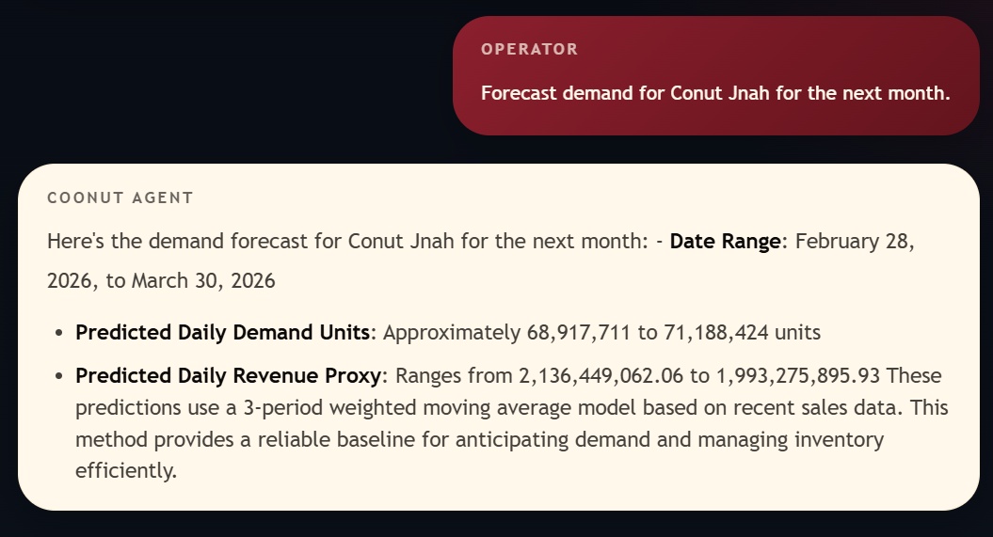
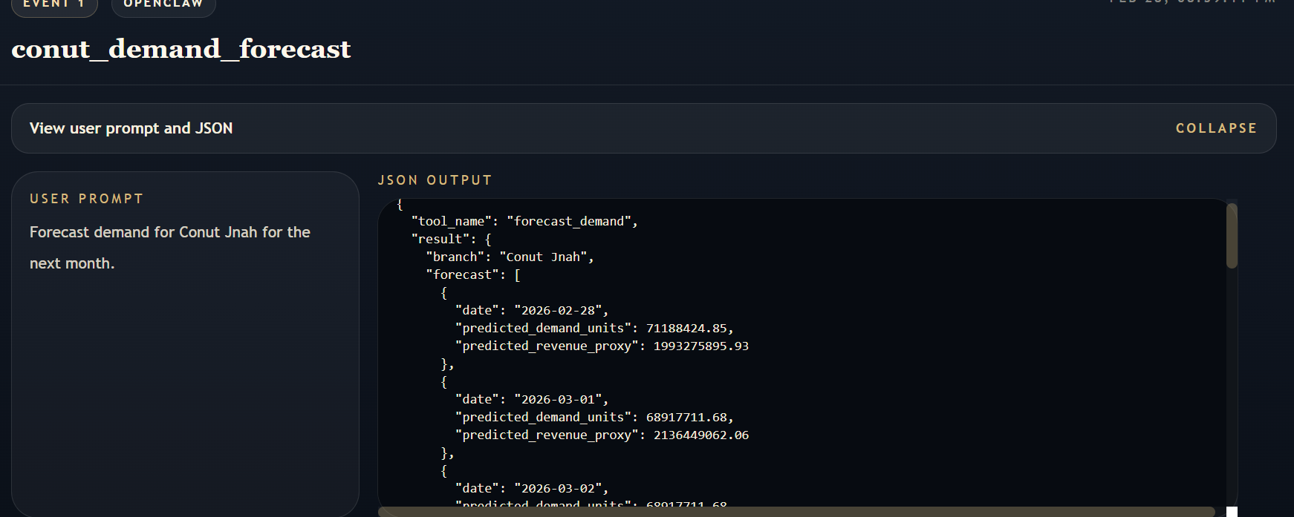

Tool 3 Expansion Feasibility:
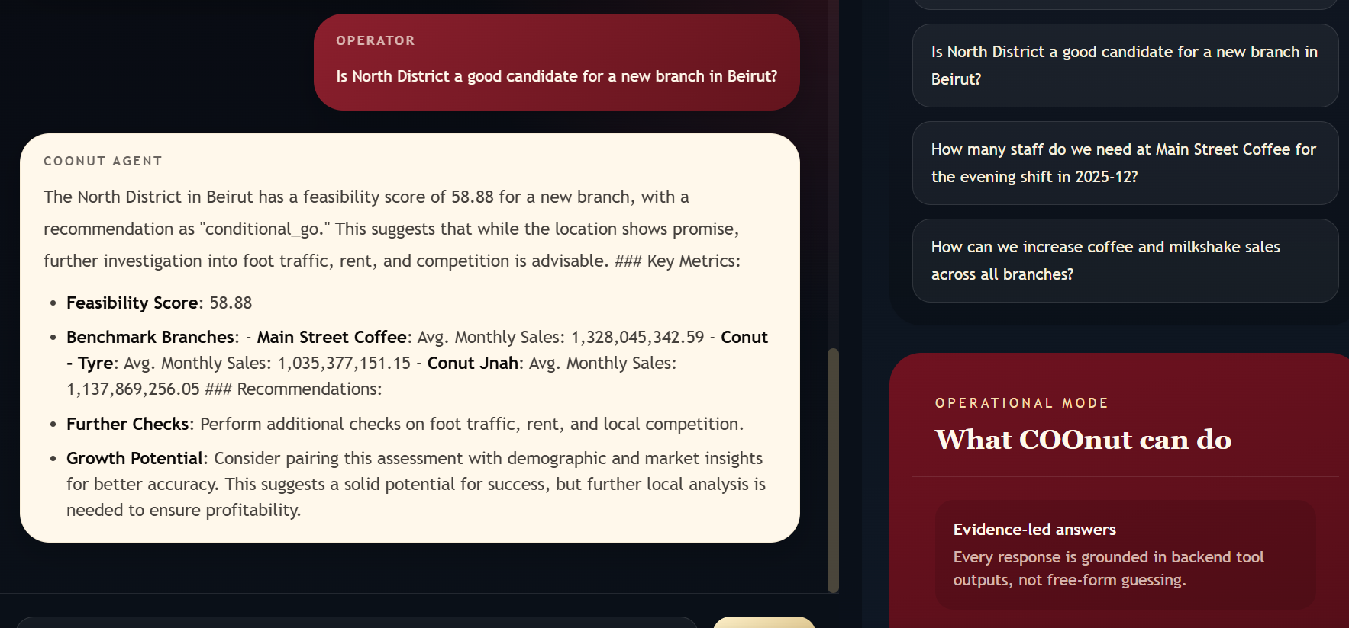
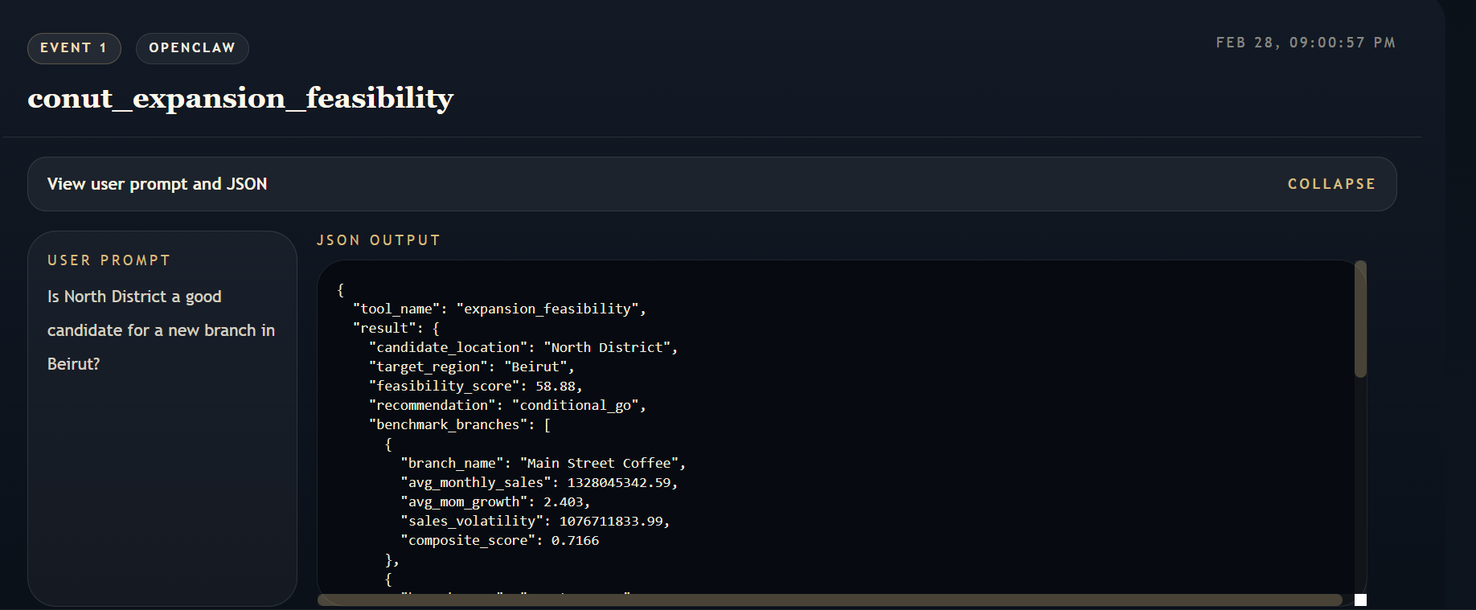
Tool 4 Shift Staffing:
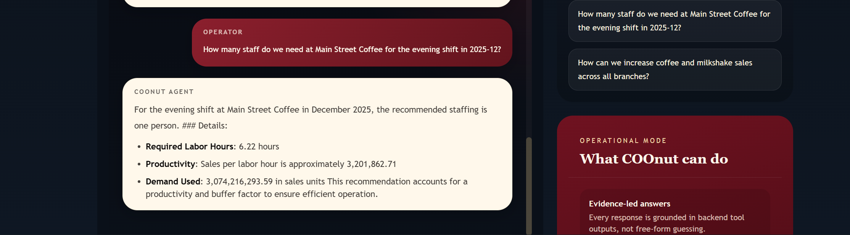
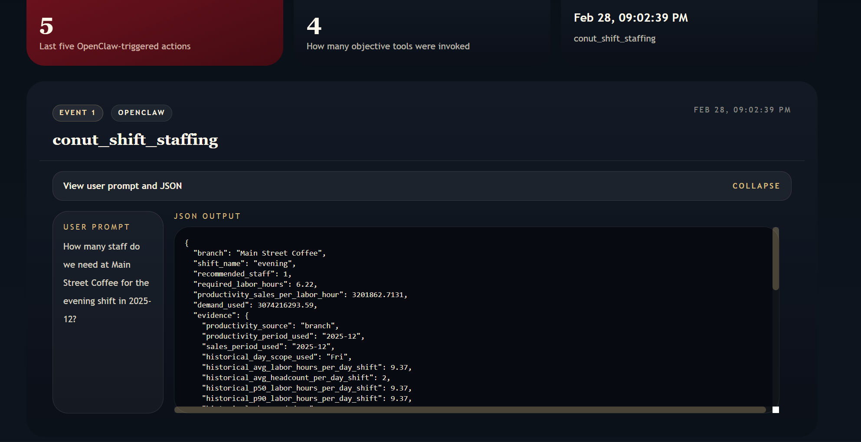

Tool 5 Growth Strategy:
